Emax-RAP- Day 9_ 31-03-2026

RAP introduction:
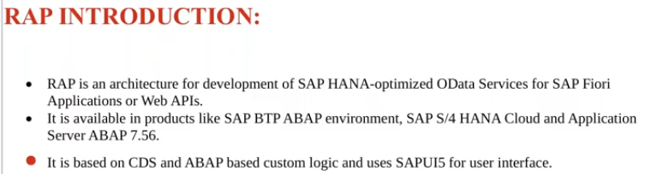

Before RAP, How Applications are created?
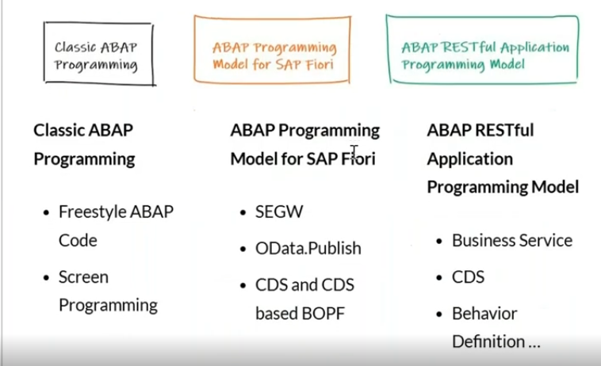
RAP- Restful Application Programing model, RAP foundation is CDS views.
if you want to create RAP application or to support to implement RAP based application - your S4 system is from 2021 released before that there is no applications for ECC system.
RAP used to implement the OData services + Fiori Apps. --> means it is not just create for APIs, it is also go to create the SAP ui5 applications, it will alone itself it will create the SAP fiori APPs which is service binding and which is the part of RAP applications, which will generate your api and also generate fiori app as well.
RAP available in BTP abap on cloud and which is s4 systems.
RAP is completely based on CDS, if any custom logic coming into the picture again it went for the ABAP based custom logic.

RAP Architecture:
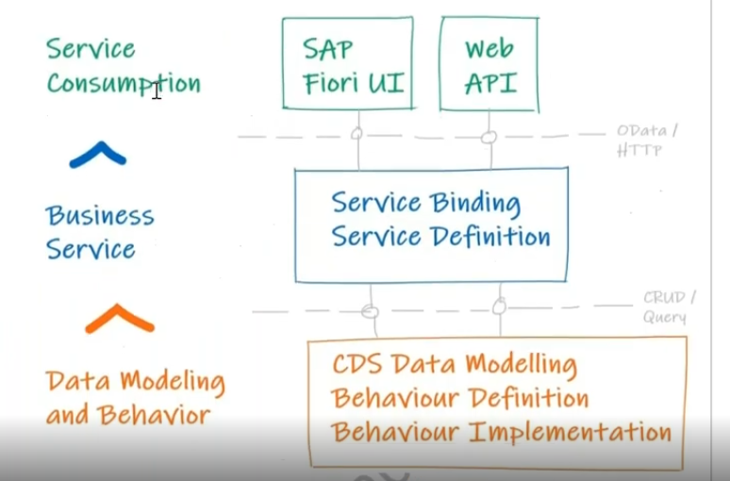

Data Modeling and Behavior:
- Data modeling - to develop the CDS views.
- While creating the CDS data modeling, we have to create the two different CDS views we have to create. one is root view and second one is projection view. these two are different templates and two different usages and we have to know, where i have to written down to the logic and where I can expose to that?.
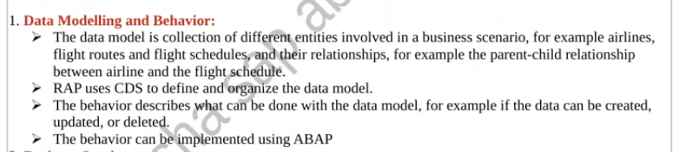

rootview:
- root view is the starting point of business object.
- Business object includes sales, customers, travels, flights,
- while creating RAP apps-.
  - first step is you have to build a data model- which is the root entity.
  - Q. can we create RAP apps with out root view.? Yes we can, but we have some limitations, if you wanted to create the read only apps- you can do with out root entity also.
here read only means- your fiori app does not contains any transactional capabilities like create/update/delete/any custom actions need to be performed/any custom validations .. etc those things you can't able to do it here- without consuming the root entity.
for create/update/delete/actions/validations- we have to go with the root entity.
with out root entity- we can create the simple read only applications.
4. in RAP always keeps your logic part in the root entity . once logic has been completed your data model is completed.

Projection View
5. Now we need to consume this data model into fiori apps. to consume any particular field or particular field to hide at ui level- any entity i want to expose or any entity i want to hide - so here projection view tell us which fields i have to expose in UI level.
Ex: i have the created a root entity, from the vbak- i have the 10 fields in root entity, we don't need to expose all the 10 fields to ui level, you don't need that- you can expose which fields are required.
6. this projection view will be created on top of the root view.- first build the root view on top of the root view build the projection view.

Behavior definition
- It describes the what can be done with the data model. for example transactional capabilities like create/update/delete, while creating a definition we have two different types of behavior definitions.
1. managed- BDEF
2. un-managed -BDEF

managed:
- No need to write the code to implement the crud operations.

unmanaged:
- developer write the code to implement the CRUD operations.
Ex:
- CRUD operations can be done through the BAPI.
- Exiting logic to use in RAP
- You can define the custom actions. you can written down the logics all your custom things you can define in the root behavior definition and implementation. - 32:00

Business Services:
1. Service definition
2. Service binding
Service definition:
i have parent and child, i have to define the projection view for both header and item but i am not exposed into the service definition, that means what all are the enities i have to exposed into the ui level which tells to the service definition.
Which entity expose into the ui level, which defines the service definition, after exposing the entities those are the entity set names. once you build the service definition final layer is service binding.
Service Binding:
Every RAP- we have to add the protocol such as v2 and V4 versions.
service binding will be created based on service definition.
While creating the service binding, you have the option whether you want only fiori api and API( odata service) or I want only api, what do you want?- this is depends on the option what to choose it.
Ex:
if fiori app is not required - binding with web api( Odata service only) - use the odata v2/v4 webapi only.
with fiori app + odata service - Odata V2/v4 only
Odata v2 -
- get the single selection only.
- You can't trigger or can't populate the value on by changing it self, v2 always trigger on save sequence, v2 not triggered on change sequence.
- File upload process will be available in odata v4 only. not in v2.
Odata v4 -
- get the multiple selection also.
- File upload also do it.
- change sequence will trigger at the time of change the record.
